Arbour Report and outline development plan – April 2021
Farnhill Parish Council had an informal socially distanced meeting at the Arbour on Saturday 10th April to discuss a plan for the future maintenance and works at the Arbour.
It was proposed:
- To take out the remains of the old stone steps at the bottom of Lower Arbour and re-set them on a new permanent path following the line of the earth path which has recently formed and join this path to the recently re-laid path to the top of the Arbour.
  - This permanent path will be created using plastic grids * filled with earth and grass seed which will grow through the grids to make the path less slippery or
  - Using plastic grids filled with river gravel to identify the path more clearly and provide a non-slip surface.
- Re-grade and improve the recently re-formed path [see photo 3] [plan 2] which leads from the bottom of the Arbour to the top by the seat and viewing area to ensure easier, safer access and compliance with Part M Building Regulations
- Starting from where the recently re-laid path has been completed, to dig up the limestone all the way round to the seating and viewing area and create a more user and environment friendly improved path by laying plastic grids *
  - Infilled with earth and grass seed.
  - Or infilled with river gravel.
  - introducing more steps appropriately spaced to reduce the incline.
  - removing the handrail and replacing with one of reduced in height [ to meet the standards for public handrails] and splinter free material.
  - To extend the handrail up to the top corner by the seating area.
- The Parish Council is aware that the road & footpath up to Arbour Top has recently damaged and deteriorated and they will continue to monitor it so it does not become a health & safety hazard.
- The definitive footpath would also benefit from having an improved plastic grid path but will be considered later as time and budget become available.
- The Parish Council believed if the steps at the bottom were re-set to join the path, then some of the washing lines would become a hazard and either the washing lines would have to be taken down when not in use or the Parish Council would provide 3 rotary lines in their place.
The above plan will be carried out in sections as time and budget allows.

This document should be read in conjunction with the Council’s Policy for the maintenance and development of the Arbour.

*see Hebden X grids or similar – britishrecycledplastic.co.uk

Plan 1.
Photo 1.
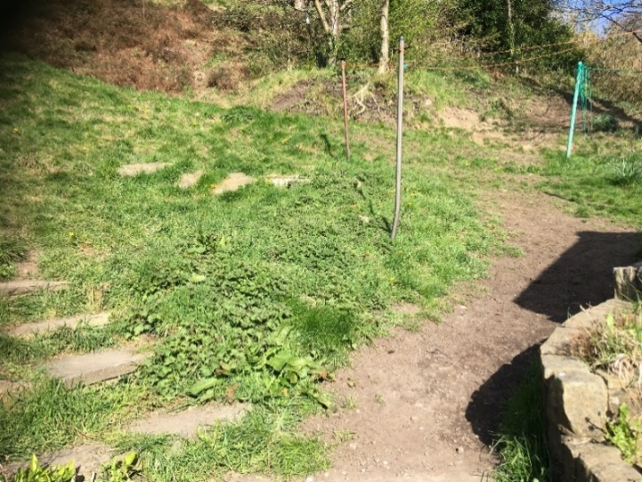
- Construct a path to follow the line of the “dirt” path from the top of the steps leading into the north of the Arbour from Main street to the recently re-laid path which leads from the bottom right of the Arbour to the top left by the seat and viewing area. [see photo 1]
- Take out the remains of the old stone steps at the bottom of Lower Arbour [the large stones piled in the grass in the centre of photo 1] and re-set them on this new path to form steps as necessary.
- If further steps are required new stone will be acquired to complete the job.
- Make good the ground where the stones have been removed and re-seed.
- This path should be Part M Building regulation compliant.
- The stones forming the steps to the left of the picture to be cleared of vegetation and made good as necessary. [see also photo 2 below]
Photo 2
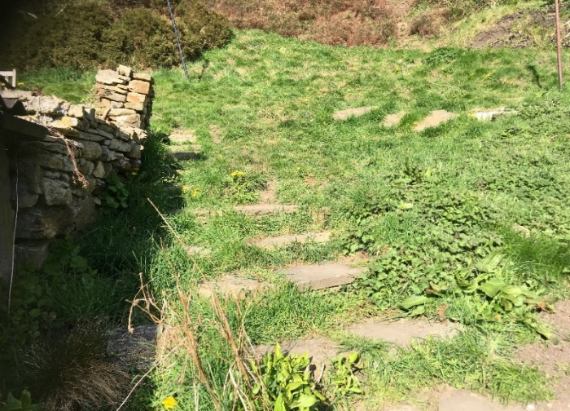

The path will consist of:
- gently inclined turf within a plastic grid *
- gently inclined plastic grids infilled with river gravel *
to ensure firm safe footing {fixed according to the manufacturer’s specification edged as necessary and appropriate using manufacturer’s edging]
Steps will be sited where necessary to enable the gradient to remain gentle and fall within the regulatory requirements of public pathways.
Steps will lead from the path onto the footpath running right to left in the top quartile of the photo.
This path will be refurbished to create a more gentle, less slippery path [ see plan 2 below
Plan 2.
Re-grade and improve the recently re-formed path [see photo 3] which leads from the bottom of the Arbour to the top by the seat and viewing area to provide easier, safer access and to ensure compliance with Part M Building Regulations.

Photo 3
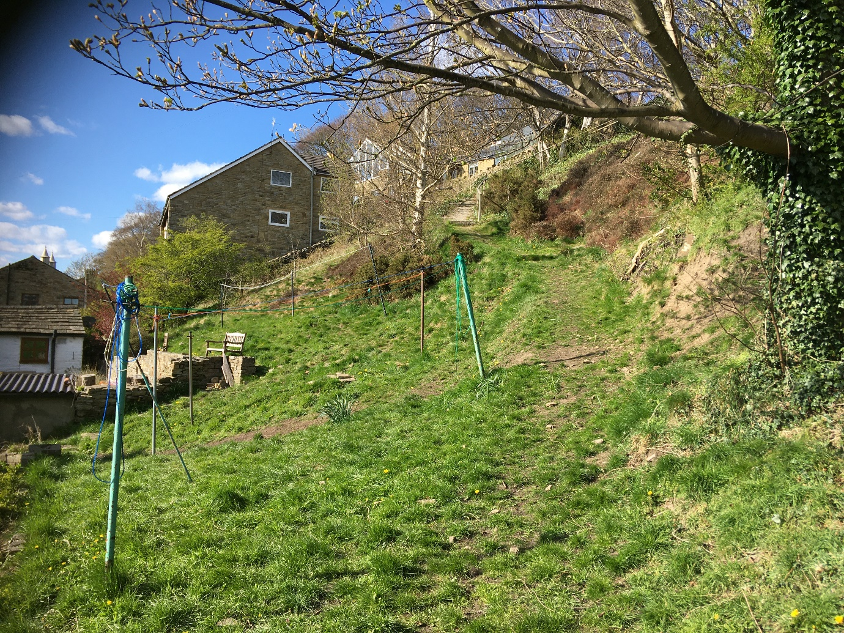

The path running from centre bottom of the photo to the first visible stone step will be regraded to lessen the gradient and to be Part M Building Regulation compliant
Wooden steps will be created as necessary to ensure a gentle gradient.
The surface will be reset with plastic path grids filled with earth and seeded, or filled with river gravel in accordance with the manufacturer’s specification, to ensure a solid gripping surface and edged with manufacturer’s edging as necessary and appropriate.
Steps will join the path from the left to provide access to the path from the northern entrance to the Arbour from Main street

Starting from where the recently re-laid path ends [see photo 4]
- remove the limestone right up to the seat and viewing area.
- lay a base layer and then plastic grids infilled with earth and grass seed or river gravel according to the grid manufacturer’s specifications,
- introduce more steps [wooden - with the possible exception of the corner] appropriately spaced to reduce the incline in line with regulations governing public paths. Ensure Part M building regulation compliance.
- remove the handrail and replace with one of reduced height [ to meet the standards for public handrails] and splinter free material.
- extend the handrail up to the top corner by the seating area. [see photo5]

Photo 4
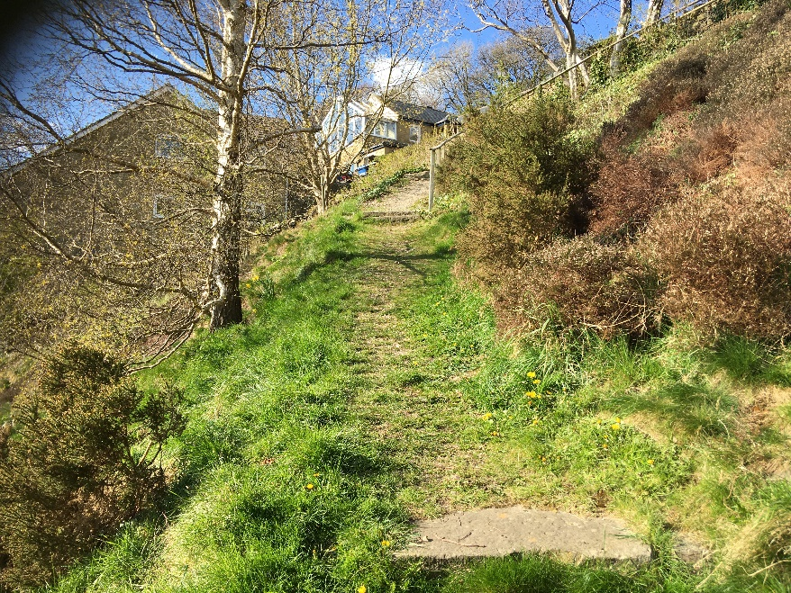

Photo 5

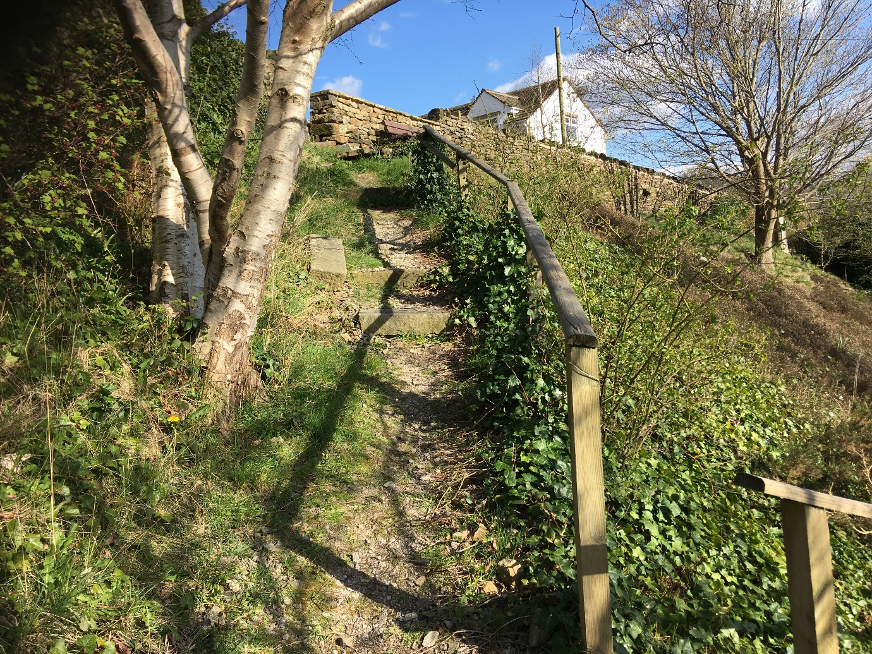

- The path will be laid to create a gentle firm gripping surface in line with Part M building Regulations and regulation for public paths
- Wooden steps will be introduced as necessary to maintain a gentle gradient in line with regulatory standards for public paths
- At the top section of the path, photo 5, an intermediate rail will be fixed to ensure the no small child could fall from the path down the steep slope to the right.
- The handrail will be extended to the very top of the path by the seat

The Parish Council are aware that the road & footpath up to Arbour Top has recently been damaged and has deteriorated and they will continue to monitor it so it does not become a health & safety hazard.

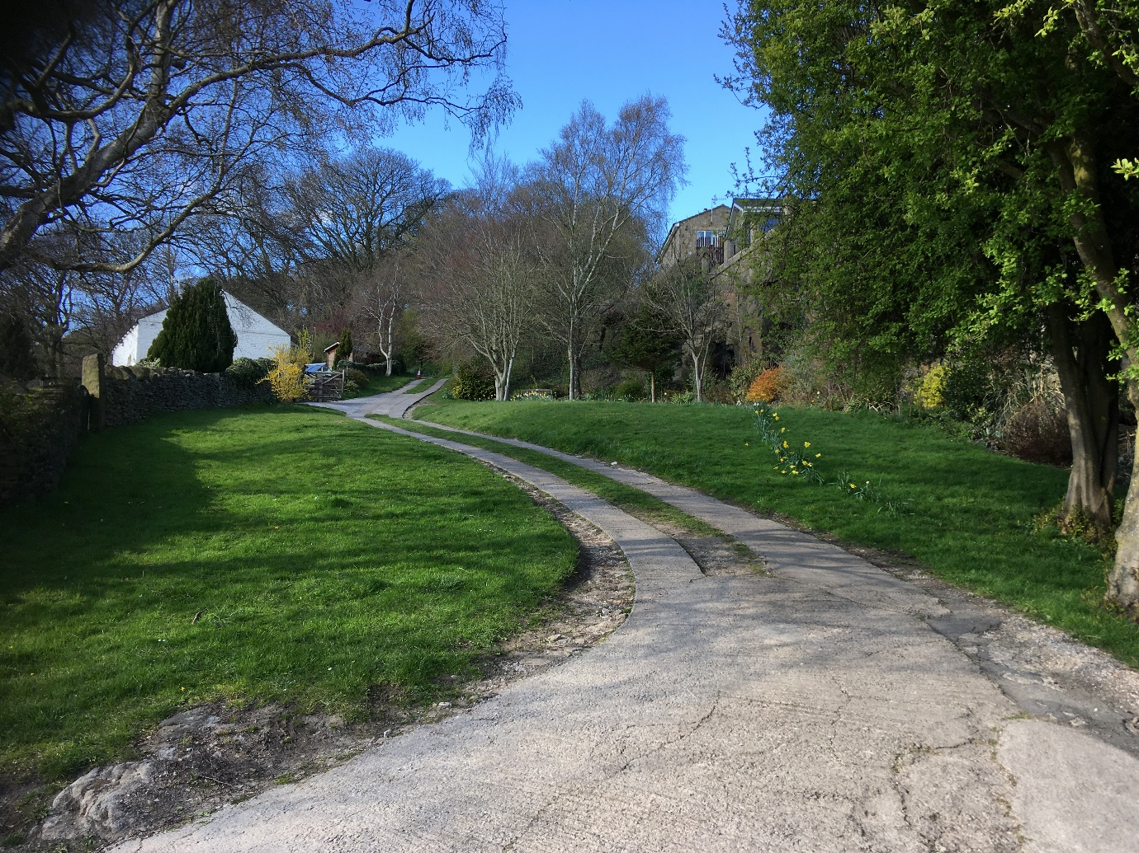

This section of the Arbour is kept trimmed by residents.
The roadway strips were installed by residents with permission from the Council some years ago.
There is a footpath from the bottom of the photo to the top along the trackway.
Some years ago, when Crag house was being converted from a bungalow into two-storey house the contractor’s vehicles damaged the edges of the concrete road strips. an agreement was reached to repair the strips but was never acted on, there being some discussion about the ownership of the concrete strips and therefore a contribution to the overall costs.
The road and path currently allow for safe access for both pedestrians using the path and resident’s vehicles accessing resident’s properties.
The council will monitor the situation.

The definitive footpath would also benefit from having plastic grids and an improved surface. This will be considered later as time and budget become available.

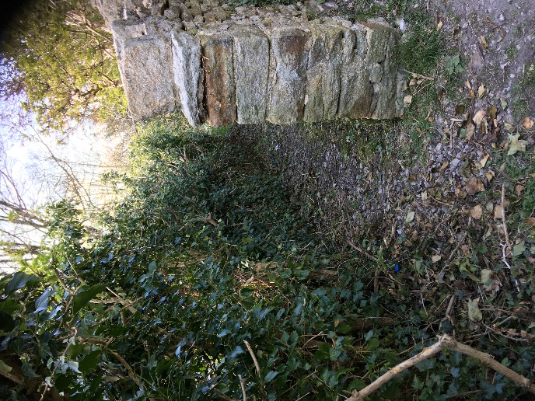
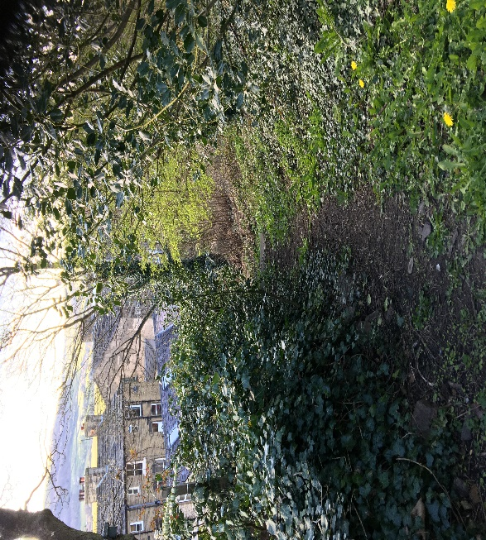
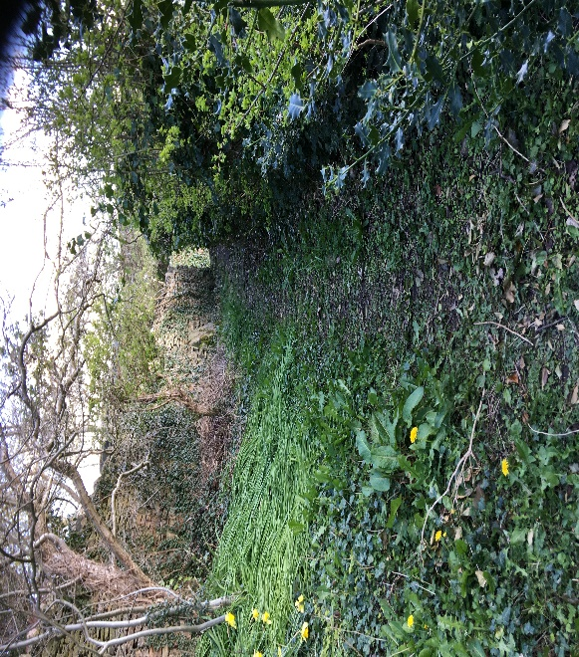
The Parish Council are of the opinion that if the steps at the bottom are re-set to join the path, then some of the washing lines would become a hazard and either the washing lines would have to be taken down or the Parish Council would provide 3 rotary lines in their place.

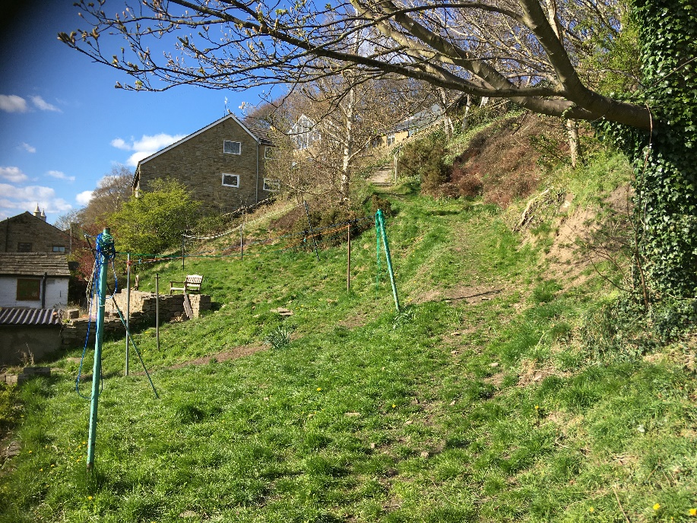
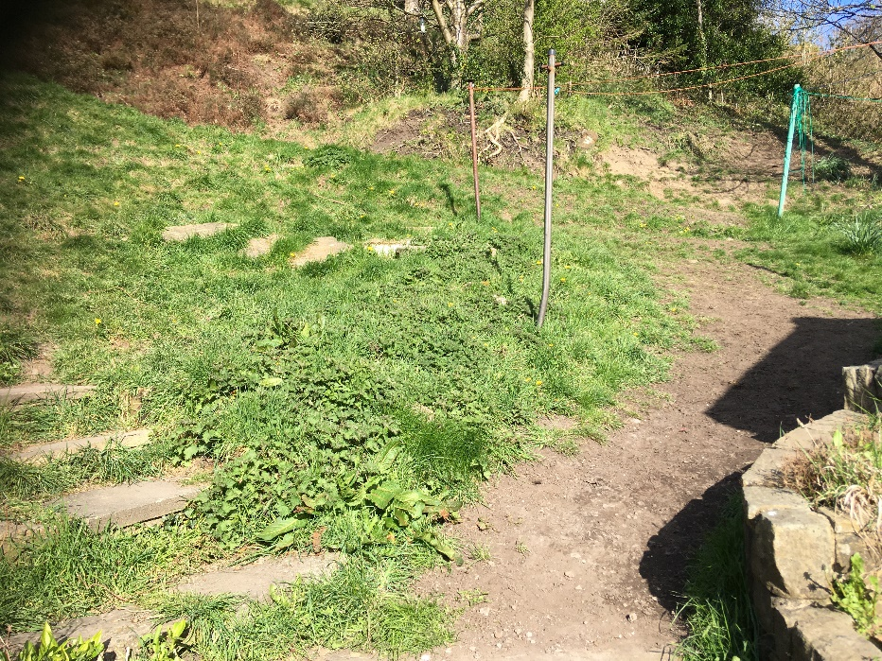

One further item was discovered whilst these photos were being shot which will need addressing. This is the damage to the recently repaired stone wall at the top left of the lower arbour next to the roadway. Here the wall has collapsed or been knocked down.

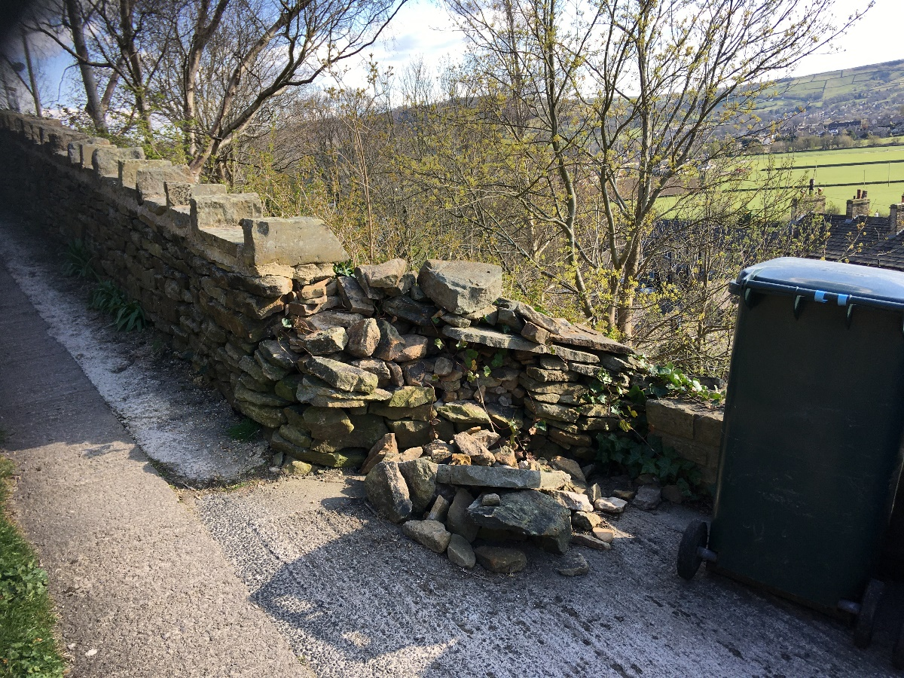

And finally, a photo showing the recently constructed viewing area and seat at the top of lower Arbour with the reconstructed stone wall which forms the boundary between the Lower Arbour and the footpath leading back down to Hanover Street and Main Street

